Generalization of methods

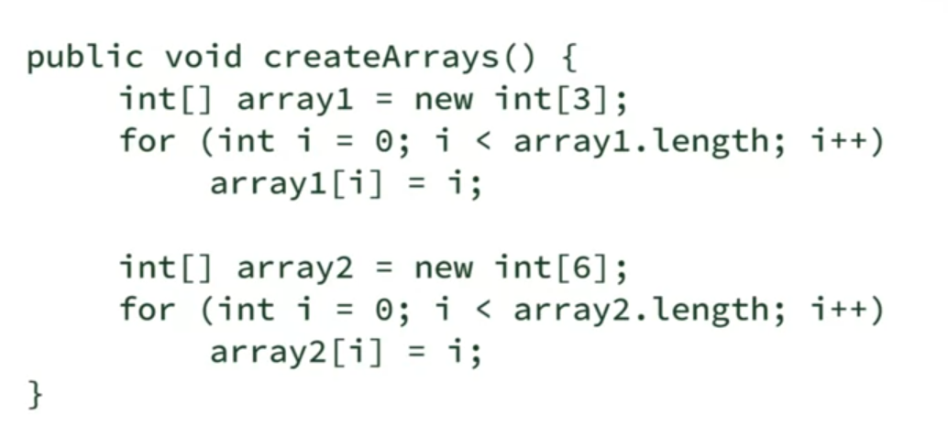



Generalization of classes

* Achieved through inheritance

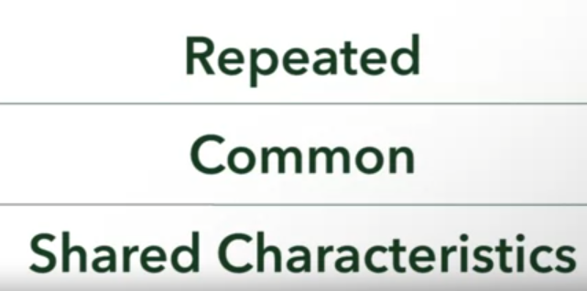

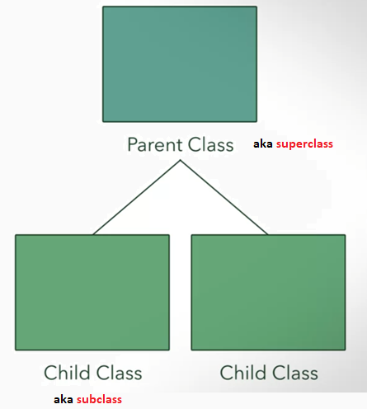

General

* Large grouping of distinct classes

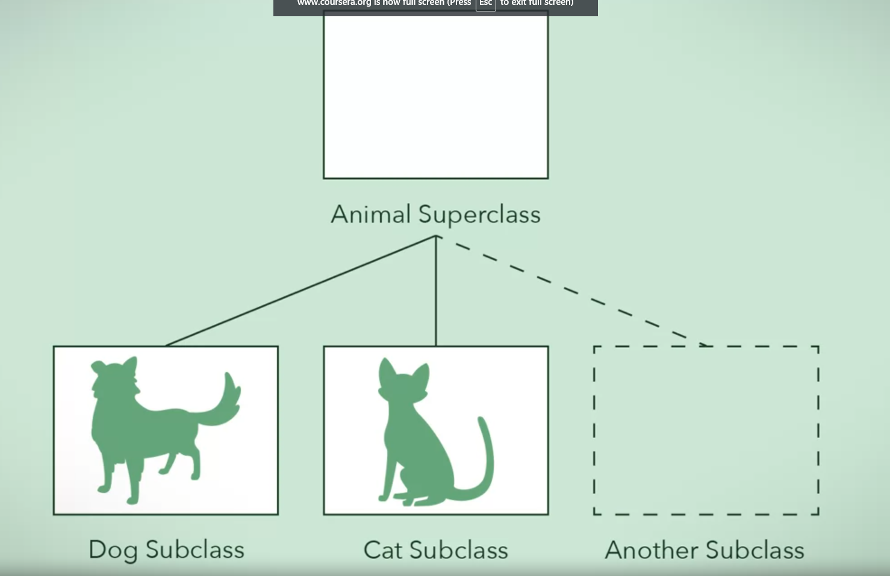

**Inheritance is used to describe the relationship between classes. What are the three ways in which this relationship is advantageous?**



Subclasses that inherit from the same superclass include attributes and behaviors from the superclass.

Correct

Correct! This is an easy way to share attributes and behaviour among related classes.



Changes can be made easily and quickly to a large group of subclasses by making changes to the superclass they inherit from.

Correct

Correct! Changes to the superclass apply to all the subclasses unless the subclasses overrides the superclass.



Superclasses can be more specialized and can pass these specialized behaviors to their subclasses.



Code can be reused through inheritance, which means we do not need to re-implement behaviors that already exist.

Correct

Correct! This is one way that you can apply D.R.Y. (Don't Repeat Yourself!)